Holiday for Giving
P.O. Box 1612 ~ Wallingford, CT 06492
Operating from:
6 Fairfield Blvd. ~ Wallingford, CT
www.HolidayForGiving.com Like us on Facebook – Holiday for Giving – Wallingford
Volunteers proud to be celebrating 51 years of spreading
Holiday Magic throughout the Wallingford Community!
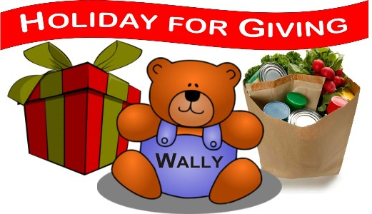

October 1, 2019

Greetings Neighbor!

Wallingford’s own Holiday For Giving (HFG) program needs your help this November!

We continually strive to expand our collection base, and hope you can join us this year in our efforts, by allowing us to place a Donation Box at your business location. Your customers and/or co-workers can then handily make much-needed donations to families in need.

Holiday For Giving is a community based non-profit organization run completely by volunteers. HFG functions solely on the generous donations provided by local businesses, organizations, and individuals. ALL donations are then distributed directly back to those in need within our town of Wallingford each December. Dozens of volunteers accomplish this tremendous amount of work through countless hours of donated time each year.

The Wallingford HFG program was founded fifty-one years ago and has run continuously since. It began as a coalition between the Welfare Department and the VNA, to help low-income Wallingford families enjoy the holiday season. The first year HFG provided for 15 families. The program has since grown to servicing nearly 300 families annually, with food and toys during the holiday season. We are based out of the Wallingford Parks and Recreation Department. This has proven to be the perfect home for us, and we are provided all the space we need, as well as support for our program and volunteers. We receive In-Kind support services from the Wallingford Youth & Social Services, the Wallingford Public Works Department and, the Wallingford Fire Department.

You may choose to help us by having your business collect items including:

Toy Drive
- Collecting a variety of new, unwrapped toys for kids ages 1 to 7 years
Food Drive
- Collecting non-perishable food items, toiletries, paper goods etc.
Magic Snowman Hat
- Collecting monetary donations from your employees and/or customers

We make it easy for you to help. We will supply you with a HFG Donation Box or Magic Snowman Hat to place in your business for your customers and/or employees to donate along with informational flyers, about the Holiday for Giving program. Your business will also be featured on our website, and other advertisements that will let the public know you are lending a helping hand, and that they can visit your business to drop off donations.

There is a true pooling of resources of volunteers, organizations, clubs, corporations, small businesses and individuals. With the dedication of time, donated goods and monetary donations from all these groups combined, we are able to provide hundreds of Wallingford families with a little "Holiday Magic" each year. Let us all help keep alive our small-town traditions of helping each other.

We hope you will join us to help us create some "Holiday Magic" for local families in need this holiday season.

If you are able to help our Wallingford community by accepting a Donation Box, please e-mail us at HolidayForGiving@Yahoo.com and:
- Provide the name and contact information (preferably e-mail) of your company representative who you would like us to work directly with. We will then be in touch to schedule the Donation Box drop-off and pick-up dates in advance.
- Specify if there is a particular type of collection (Toy/Food/Magic Hat) you prefer. You can select one or a combination; whichever you prefer.

Thank you in advance for your consideration,

Elizabeth Guidone and Joellen Vollano Nellums
Holiday for Giving Drive Coordinators
203-427-3334 HolidayForGiving@yahoo.com

Committee Members…all Volunteers:
Jenn Lavoie, Dana Masson, James Lillis, Adriana Rodriguez
Youth & Social Services Advisors: Craig Turner & Kim Stein

